IMPLMENTING CRM FOR RESULT TRCKING OF A CANDIDATE WITH INTERNAL MARKS

INTRODUCTION:

OVER VIEW:

**Administrator should be able to create all base data including Semester, Candidate, Course and Lecturer, Lecturer should have the ability to create Internal Results, Dean, who is one of the Lecturer, should be the only one with ability to update Internal Results, Re-evaluation Can be initialized by Candidate for all Internal Results. Now only dean can update the marks after re-evaluation.**

PURPOSE:

It aims to produce areal time knowledge of the salesforce and how can we build a app using salesforce in this project we build a Candidate results card application for educational institutions ,which would be useful for the staffs to reduce time and track the performance of the students with ease.it is helpful to have large number of data maintained under one platform.

PROBLEM DEFINITION AND DESIGN THINKING

EMPATHY MAP

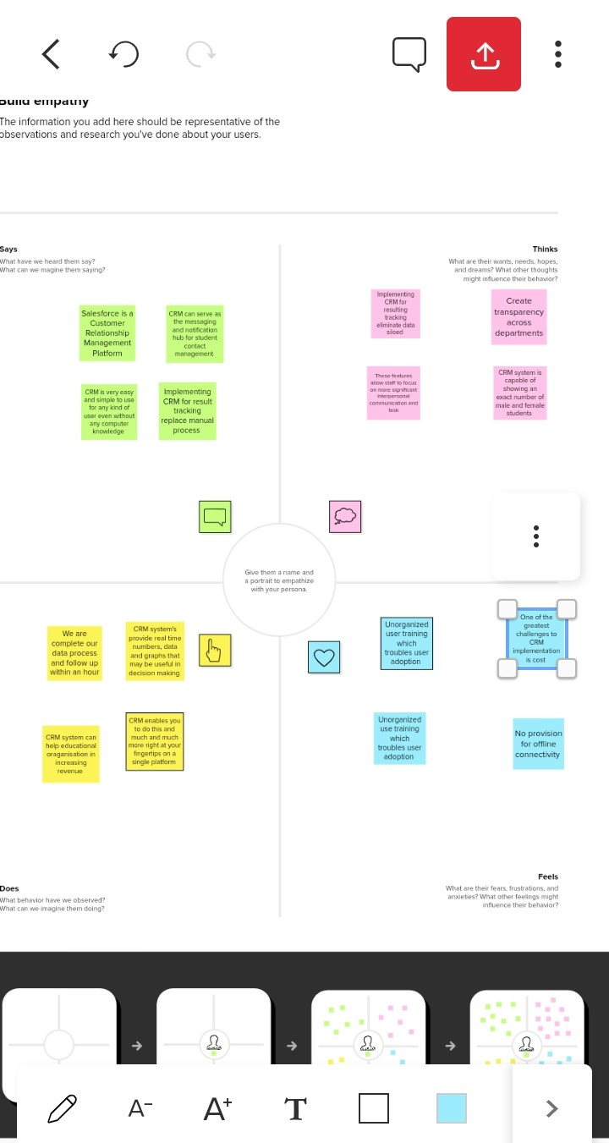

IDEATION AND BRAINSTORING MAP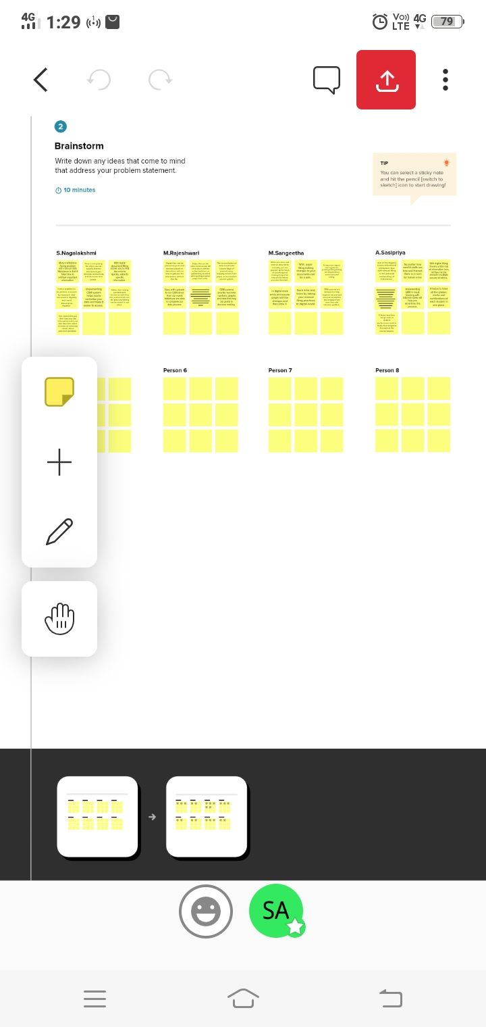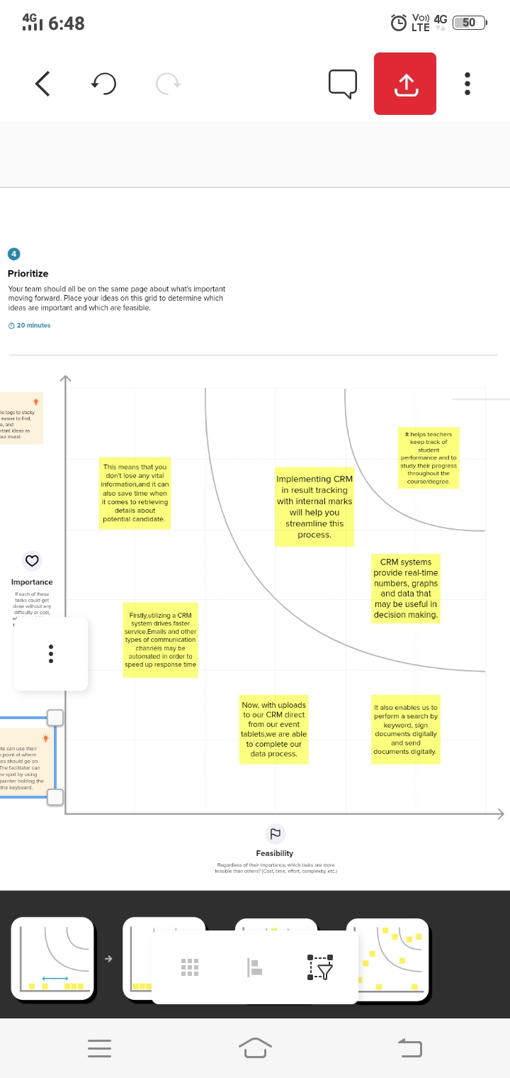

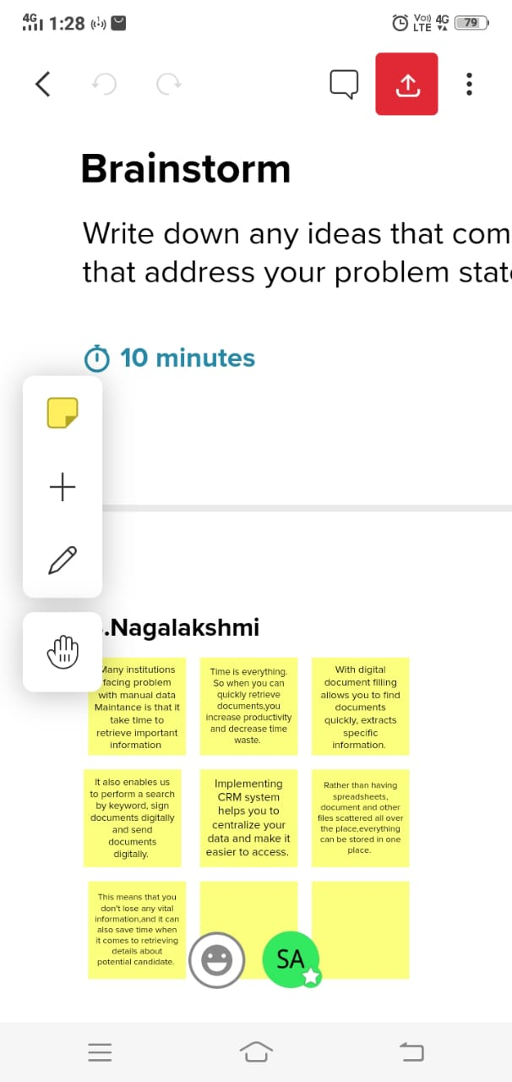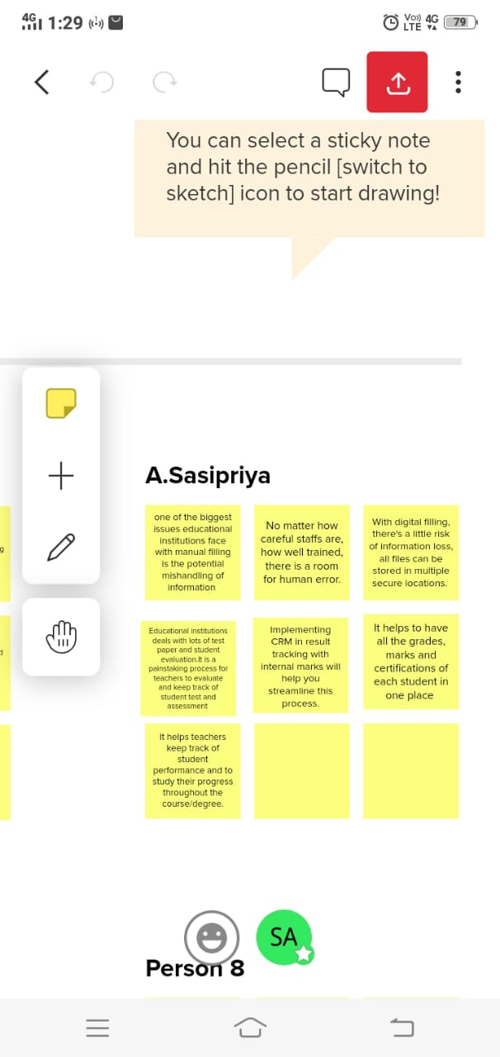

RESULT

|  |  |
| --- | --- |
| OBJECT NAME | FIELDS IN THE OBJECT |
| SEMESTER | FIELD LABEL:  SEMESTER NAME  COUSE(LOOKUP)  DATA TYPE:    TEXT |
| CANDIDATE | FIELD LABEL:    CANDIDATE NAME  CANDIDATE ID  SEMESTER NAME  INTERNAL RESULTS(LOOKUP)  DATA TYPE:  TEXT |
| COURSE DETAILS | FIELD LABEL:    COURSE NAME  COURSE ID  DATA TYPE:    TEXT |
| LECTURER DETAILS | FIELD LABEL:    LECTURER ROLE  LECTURER NAME  COURSE ID  COURSE(LOOKUP)  DATA TYPE:    TEXT |
| INTERNAL RESULTS | FIELD LABEL:  CANDIDATE ID  COURSE ID  MARKS  DATA TYPE:    TEXT |

ACTIVITY AND SCREENSHOT

CREATION SALESFORCE ORG

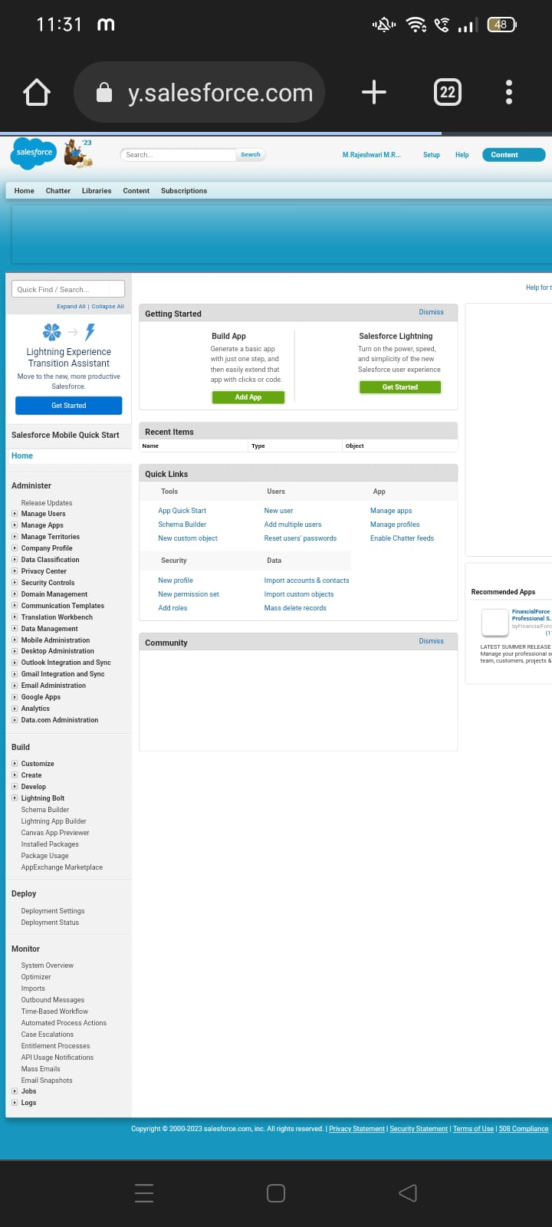 We have created an developer account for salesforce account. Salesforce is your customer success platform.

Our mail id and name are given to get developer account.

CUSTOM OBJECT:

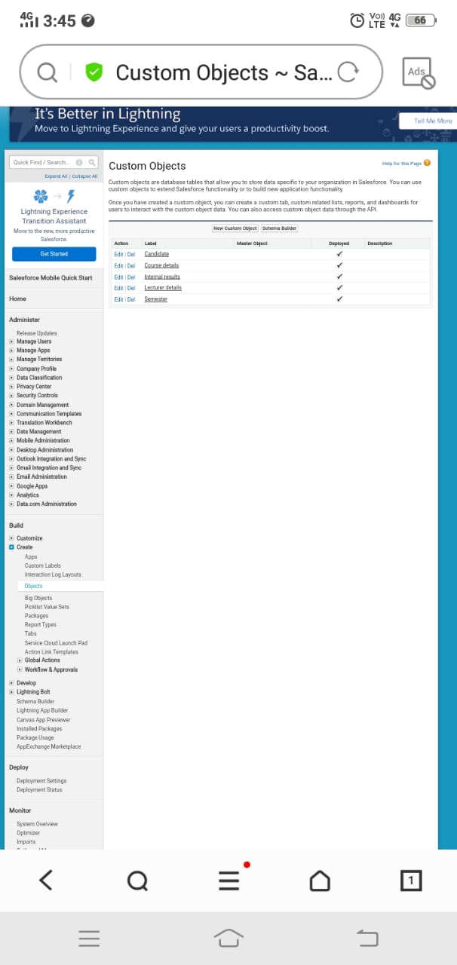

Creation of objects for candidate internal result card, for this candidate internal result card we need to create 5 objects that are Semester, Candidate, Course Details, Lecturer Details, Internal Results.

FIELD AND RELATIONSHIP

CREATION OF FIELDS

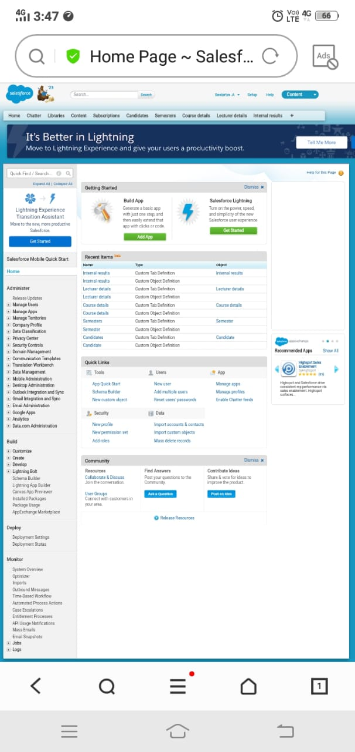

Relationship are created custom relationship fields on an object. This is done for the users to view, records, they can also see and access related data.

LIGHTNING APP

CREATE THE CANDIDATE INTERNAL RESULT CARD APP

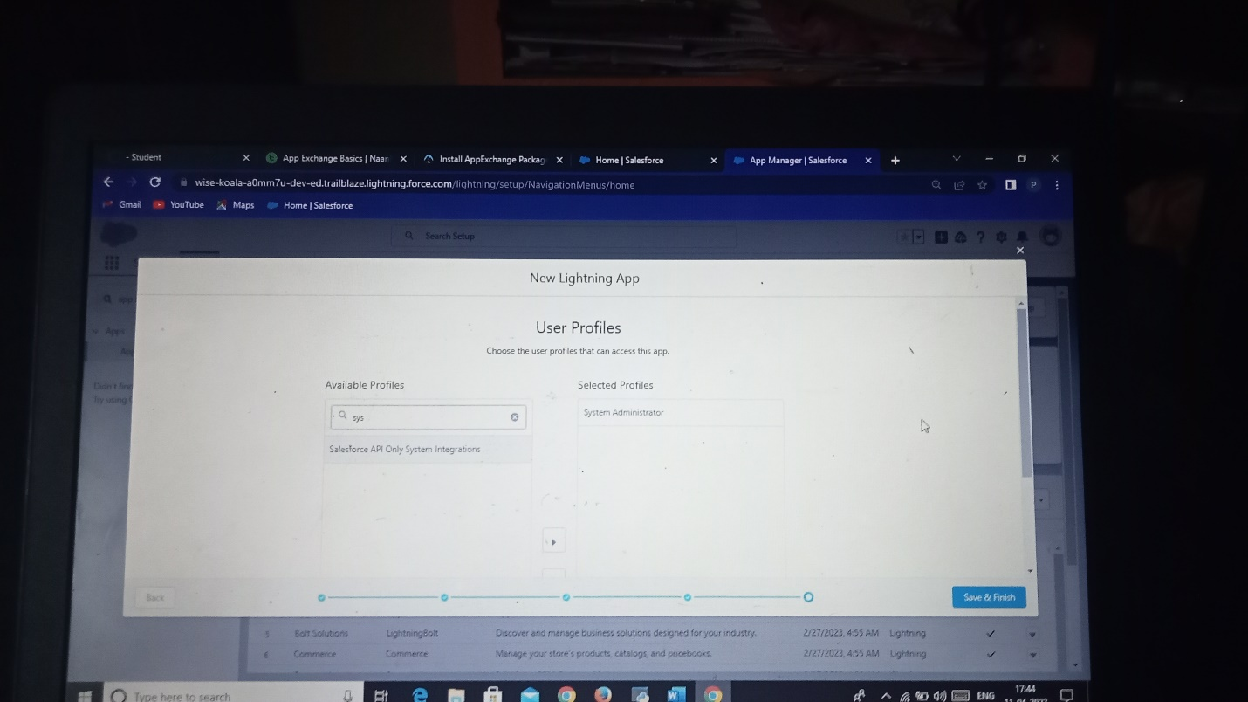

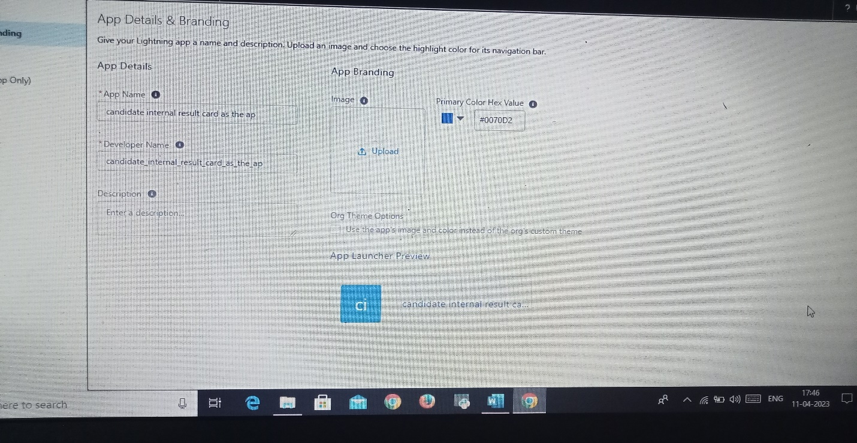

App in Salesforce are a group of tabs that help the application function by working together as a unit. We have created the lightning app of candidate internal result card.

USERS

CREATING A USERS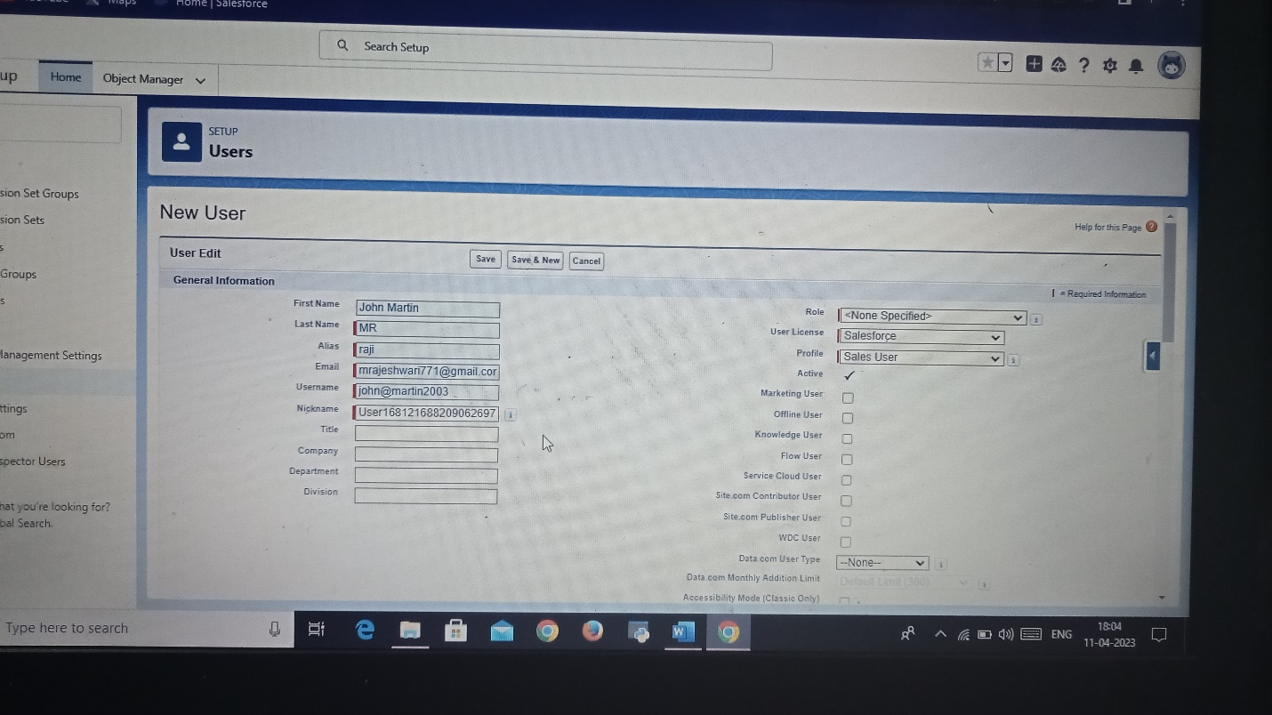

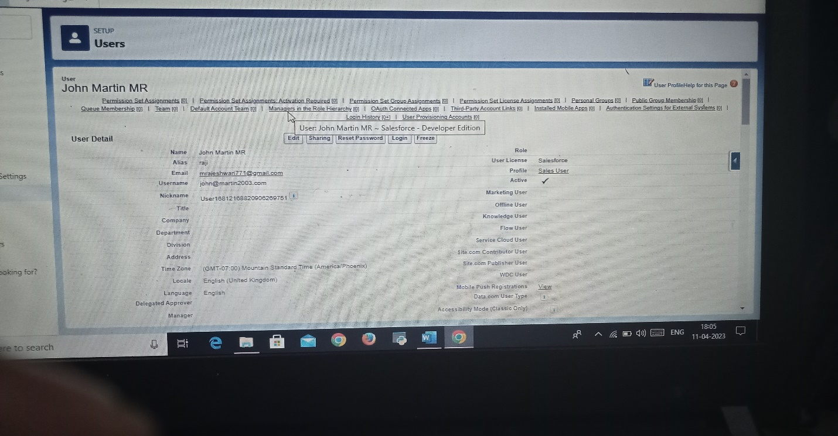

every user in salesforce has a user account. Click setup enter user, select new user , enter the details, we create a new user.

REPORTS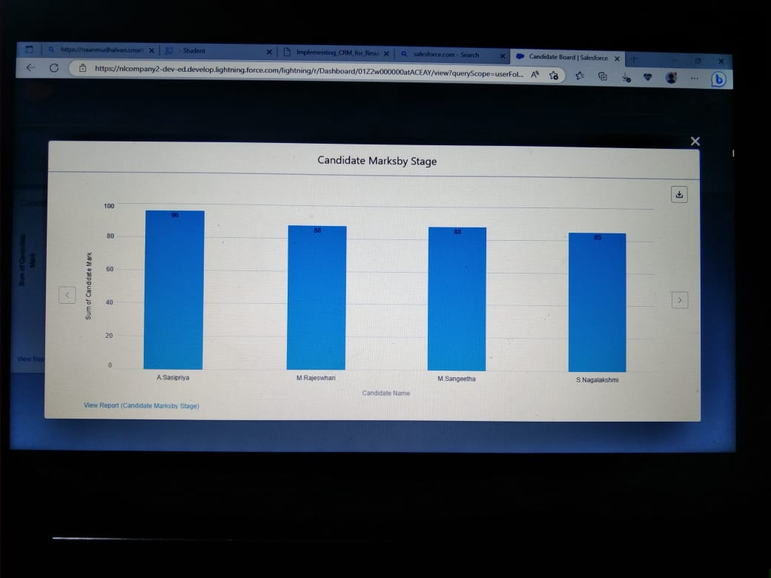

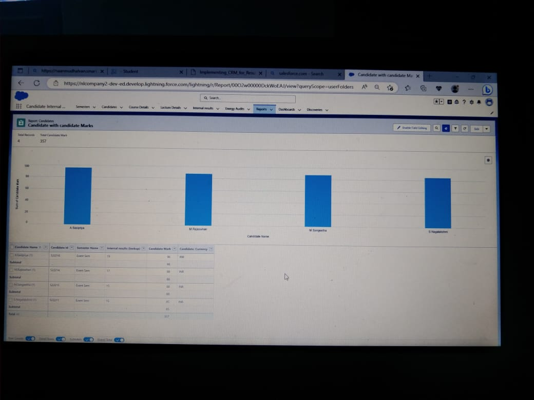

A Report is a list of records that meet the criteria you define. Its is diplayed in salesforce in the form of rows and columns, and can be filtered, grouped, or displayed in a graphical chart. Every report is stored in a folder.

DASHBOARDS

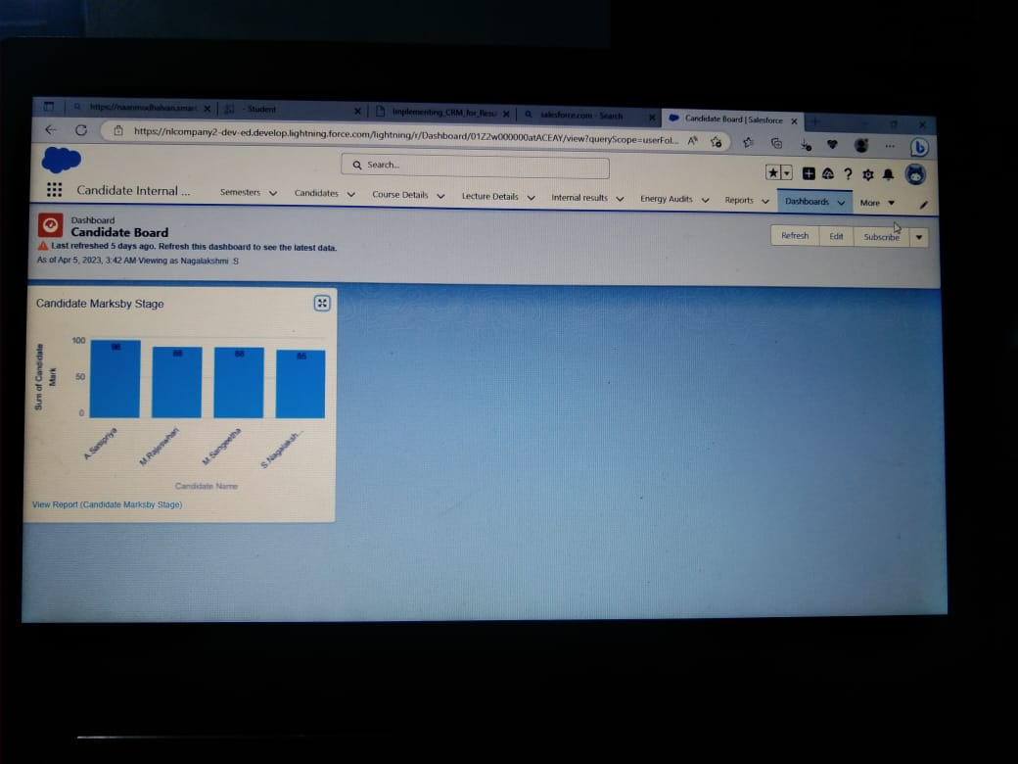

Dashboards let you curate data from reports using charts, tables, and metrics. Dashboards filters make it easy for users to apply different data perspectives to a single dashboards.

TRAILHEAD PROFILE PUBLIC URL

Team Lead-<https://trailblazer.me/id/nagas210>

Team Member 1-<http://trailblazer.me/id/mmrajeshwari>

Team Member 2-<https://trailblazer.me/id/sangeetha2405>

Team Member 3-<https://trailblazer.me/id/sasipriyaa>

ADVANTAGES

1. It helps teachers keep track of student performance and to study their progress throughout the course or degree.
2. Implementing CRM in result tracking with internal marks will help you streamline this process.
3. CRM systems provide real-time numbers, graphs and data that may be useful in decision making.
4. It also enables us to perform a search by keyword, sign documents digitally and send documents digitally.

DISADVANTAGES

1.Software subscription or purchase fees

2.Premium upgrades, eg add-on marketing or reporting features

3.Customisation

4.IT resources needed

5.Hardware or software requirements

6.Staff training and upskilling

APPLICATIONS

Implementing CRM in result tracking can be used in all educational institutions to track candidate results.

It can be used both in schools and colleges.

In schools, college even in universities, it would be very useful in monitoring students performance and records.

CONCLUSION

Educational institutions deals with lots of test paper and student evaluation.

It is a painstaking process for teachers to evaluate and keep track of student test and assessment.

So we have came up with a solution known as implementing CRM in result tracking with Internal Marks.

We have customized objects, fields and created Candidate Result card app in that app e create reports and customized dashboard showing marks of student as vertical bars.

By this app we can show the students result in graphical representation which in easier to manage their results.

FUTURE SCOPE

OMNICHANNEL DASHBOARDS-

Deeply integrates with social media, websites, cloud telephony, and other software to bring all queries to a unified dashboards.

AUTOMATIONS-

AL-powered bots, automated feedback or information form collection, and canned responses save time for your staff.